AG05 - Appendix 1



*Communication, Consultation, and*

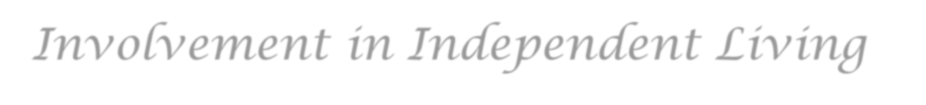

*Involvement in Independent Living*



Scrutiny

Winter



2023

Communication, Consultation, and Involvement in Independent Living **Introduction**

This review is part of the Scrutiny Programme for 2023/24 as agreed with involved customers.

**Greatwell Homes staff who manage the service:**

Sean Jackson, Sophie Willson and Lizzie Brown

The Scrutiny review will look at:

1. How Greatwell Homes communicates with Independent Living customers
2. How the Support Services team communicates with Independent Living customers
3. How Independent Living customers are consulted on relevant services
4. What we know about Independent Living customers’ communication needs

**Objective:**

The purpose of this scrutiny is to review communication and consultation specifically for Independent Living customers. To provide suggestions on developing a holistic approach to communicating with Independent Living customers by understanding specific needs of IL customers. To define a consultation process and feedback process to IL customers.

Providing customers with a sense of empowerment and feeling that they are adequately informed.

as per our Live Proud strategy, and being more inclusive to customers’ needs as per our Live Happy strategy.

**Determining Questions:**

1. How can Independent Living customers be adequately informed and have a voice on new service provision and changes to existing services?
2. How can Greatwell Homes hear customers’ concerns and address them accurately for all Independent Living customers?
3. What is best practice around consulting customers with vulnerabilities?
4. How can communication methods be adapted to meet the needs of Independent Living customers, particularly those that are harder to reach.

**Exclusions:**

The performance and operation of OK each day service by Alert-a-call

Tunstall / call monitoring service provision and performance

The day-to-day running of the Independent Living service

Individual staff communication styles and performance

The functionality of the Greatwell Homes website

# Tenants that took part

Sharon Medlin, Mary Reeves, Steve Patis, Amanda Northfield,Jade Matthews Nana Ama Mensah.

# Other housing providers

Westward Housing, Two Rivers Housing, Papworth Trust, Great Places Housing Group

**Policies Review:**

Communications Framework

· Customer Involvement Framework

· Equalities Act 2010

· Equality, Diversity, and Inclusion Policy

· Live Happy Strategy

· Live Proud Strategy

· Professional Standards

· Quality Standard – Future Vision for Independent Living

· Reasonable Adjustments Policy

· Tpas Accreditation Report

**Customer Survey:**

We had a 26% response rate, 66 responses in total (19 by email and 47 by paper) we only have 138 (55%) email addresses of Independent Living homes. Paper surveys achieved a higher response rate than email surveys. There are a total of 253 customers, including bungalow schemes.

35% of customers stated they have not been asked about their communication preferences. These customers could include the harder to reach as they have not been given a chance to inform Greatwell Homes how they prefer to be communicated with. 27% could not remember so these also could include the harder to reach customers.

From the survey one customer said they liked to get reminders and getting information on a noticeboard. Language barriers could cause customers to be harder to reach if English is not their first language and may find it quite difficult to understand especially if information is complicated. One customer has stated letters to be printed in their language and having a translator present during phone calls and meetings. Send letters with larger print for the customers that need this due to worsening eyesight.

0

5

10

15

20

25

30

35

40

Letter

Email

In-person

Phone call

Text

Message

Ok Today

Contact

Family

Large Print

Left Blank

What’s your communication preference?

Tenants could pick more than one option when stating their communication preferences

# Customer focus groups

We went to four Independent Living Schemes which included Earls Barton, Charles Robinson, Knights Court and Walker's Way in Finedon. We talked to a total of 25 tenants from the four schemes.

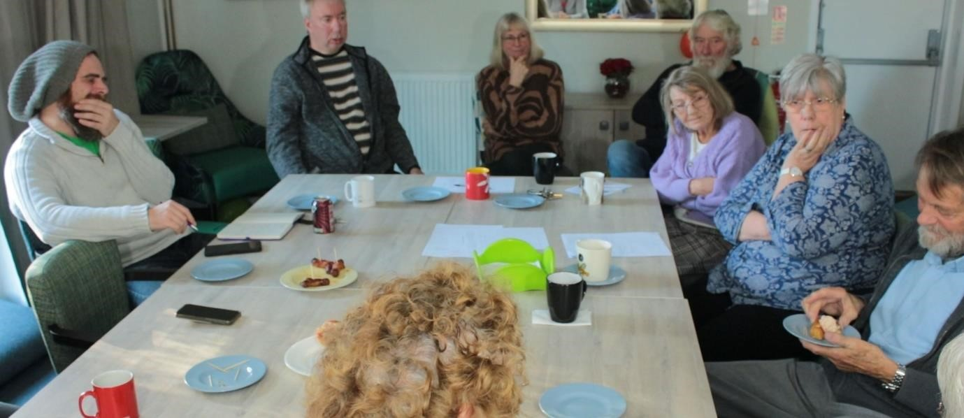

We asked the tenants about communications with Greatwell Homes here are some of their responses.

# Communication

* Greatwell Homes needs to communicate with the tenants in the format of their choosing rather than depending on staff.
* When reporting issues to an ILO about communal areas, some issues are unresolved and feedback is not always shared, leaving residents feeling unvalued not listened too, not respected.
* Several tenants stated they liked the Ok today system for getting messages, it works well.
* TV screens not working or resident(s) turning off/taking USB stick, TV’s going missing. They are not secured to the wall in a way that would prevent this as per recommended in a previous scrutiny.
* Some letters come in plenty of time, but some come with just a few days left to respond.

# Consultations

* The consultations for the refurbishment of communal spaces were chaotic, no resident we spoke to liked the overall design.
* Some tenants at Charles Robinson Court told us they were not kept up to date when works are due to start or delayed and were not advised when plans changed.
* One scheme has lost access to their garden and have been given no information regaining access.
* Tenants were not told when the plans for refurbishment changed or given a chance to discuss or agree to the changes.

The issues above relate to the determining questions 1,3 and 4 . Scrutiny found that many tenants were unhappy with Greatwell Homes and there is no trust or belief in promises.

Consultations and Health and Safety done from the perspective of the staff and not the residents, with care needs. This needs to be addressed because it appears Greatwell Homes are not listening to the concerns of their residents in Independent Living schemes.

**Staff Focus Groups:**

Staff said that they use a variety of methods when communicating with tenants and stated that when doing consultations frequently one tenant will try imposing their opinion on other tenants. The way round this is to send out individual questionnaires after the consultation.

The ILOs said that the TV’s with the memory sticks work really well when working however there are issues where some only work for short periods of time and one gets stuck halfway through the message these issues need sorting out. In Finedon the issues are slightly different as the community room is only open for a few hours twice a week. We believe it would be better if an outside notice board was erected instead of replacing the TV this would probably be a more cost-effective end of more help to the tenants.

Staff said that they have access to two different methods of communicating with tenants whose English is a second language. This could include taking another member of staff along who speaks the person’s language to translate. The other method is to phone a translator.

We were told that Greatwell homes keeps a record of how the tenants like to be contacted (letter email phone call in person). We found this to be only applicable to newer tenants, this needs to be rectified. We realise that Greatwell Homes is aiming to be paper free BUT this is not how some of our tenants wish to be contacted and they do not have the facilities for emails. We found that Greatwell Homes no longer has prepaid return envelopes for staff to use. As our questionnaire were delivered by hand some of the tenants did not want to hand them back to the ILO’s back because they felt that their privacy and anonymity was compromised.

We asked additional questions to staff.

The Support Services Manager told Scrutiny that communication preferences are not at present asked on the 6 monthly support plans nor the 12 monthly risk assessment.

We asked if the Independent Living officers have passed on residents preferred / requested forms of communication.

The Head of Property Investment is working with infrastructure providers to get full broadband into all the schemes including ILO offices. This will happen in about 18 months

You said the future vision of the Independent Living document, all flats to have IT infrastructure in all habitable rooms. This may help in the future for them to have access to the internet

A lot seems to be happening in 18 months that residents aren’t aware of. People are going to need time to process the information being given and potentially make arrangements. This leads to no transparency. Not being open and poor communication between Greatwell Homes and residents.

# Final Conclusions

The methods of communication currently used by Greatwell Homes are.

* TV’s and Noticeboards
* Letters
* In-person
* Email / online portal – website.
* Phone call
* Text Message
* Ok Today

We as a scrutiny team are grateful that the staff and tenants have the confidence to speak freely and openly to us. We found that Greatwell Homes needs to do a lot of work to regain the trust of tenants.

During customer focus groups and staff interviews, several issues were raised to the group, which we have raised outside of this report as they were out of scope. We have met with John Ross who has assured us that he wants to address the concerns raised.

Items removed during refurbishment have not been replaced or items placed in communal lounges were not chosen by tenants. Reduce furniture in smaller schemes to allow tenants to manoeuvre safely. These chairs could be used to replace unsafe chairs at other schemes.

New door entry system installed without a consultation, does not safe guard tenants, as tenants cannot see who is coming in. Although visitors can be seen on a channel on the TV, by the time the TV is turned on, then turned to the correct channel, the visitor has either been let in by someone else or left because they believe the person is not at home. Independent living tenants need easy to operate systems.

Greatwell Homes put a post up on social media and website that stated one tenant said it was fabulous. This was not the opinion of most of the residents the scrutiny team spoke too. Greatwell Homes needs to be extremely careful when making self-congratulatory posts with little to no evidence.

An article in the Guardian stated.

*Caroline Abrahams, the charity director at Age UK, said it was good to see older people crossing the digital divide and that being online could offer a range of benefits. However, she also warned: “There is a need for more support to help those older people who want to go online to do so, but it’s also vital that those who aren’t IT users can continue to access services of all kinds in other ways.*

*“They shouldn’t be forced into a digital world just because it cuts costs for business or the government – we should be using digital tech to expand choice for people, not restrict it.”*

Feedback not requested after work done in schemes.

To rectify these issues even with the recommendations actioned, will take commitment from all levels of staff.

A very big Thank You to all the scrutiny team members for helping in putting together all the data and information that has helped make this report possible. Thanks Guys if it wasn’t for your help and dedication we could not complete our scrutiny reviews.

Please keep up all your great work and efforts !

# Recommendations

|  |  |  |  |  |  |  |  |  |
| --- | --- | --- | --- | --- | --- | --- | --- | --- |
|  | **Recommendation** | **Objective / benefits of recommendation** | **Evidence** | **Determining Question** | **Agreed action – put in Clearview** | **Management Response** | **Delivery date** | **owner** |
| 1  1.2 | Create a project management guide with customers with specific focus on Independent Living.  For those unable to attend a consultation, an outline of what’s being proposed should be sent out. An agree/disagree portion and possibly an A  ‘Any Comments’ to be completed. This could then be returned anonymously and placed in a drop box. | The guide should include:  consult right from the start  clear communication of what was discussed and agreed  review of each consultation  lots of notice of consultation  flexible opportunities to give private and public feedback and a review of the new service after 3 months.  Consultation to be carried out with survey fatigue in mind. Coordinate consultations and surveys with other teams.  Project management guide to be for all customers, to include Independent Living. | Document review shows there is no current consultation process.  Customer surveys and focus groups have provided requests from customers. | 1. How can Independent Living customers be adequately informed and have a voice on new  service provision and changes to existing services?  2. How can Greatwell Homes hear customers’ concerns and address them accurately for all  Independent Living customers?  3. What is best practice around consulting customers with vulnerabilities?  4. How can communication methods be adapted to meet the needs of Independent Living  customers, particularly those that are harder to reach. | **Create a project consultation guide with customers with specific focus on Independent Living.** | **Agreed** this guide should focus on key aspects of consultation as mentioned in the recommendation. Suggested change to the name as Project Consultation Guide.  1.2 will be addressed in the consultation guide around consulting in multiple ways and what to do if people can’t engage.  Consider if meetings might clash with other Greatwell Homes meetings. | End Q2 – Sept 2024 | Community Involvement Manager |
| 2 | Support Services manager to attend residents meetings or consultation meetings.  Meetings to be minuted and made available to all customers in the scheme. Customers will have the opportunity at the end of the meeting to agree the minutes and actions. | This will provide accurate information and the manager is able to provide answers straight away.  This will help hold staff accountable for what is said in meetings and improve trust. | Staff interviews and customer focus groups | * How can Greatwell Homes hear customers’ concerns and address them accurately for all Independent Living customers? | **Support Services manager to attend residents meetings or consultation meetings.** | **Agreed**. This has been done on several occasions in the past, we have found when the Manager attends it takes all focus off the ILO as the first port of call. Going forward we will allow the ILO to lead any meeting in their scheme, this is still with the presence of the Manager for support purposes only.  The support services manager would take notes as part of the support role.  Adequate time to be given for meetings – if they over run or allow longer meetings where debate is likely. | End of Q4 – March 2025 to give a full year of evidence. | Support Services Manager |
| 3 | Do an audit on communication preferences on all Greatwell Homes customers (not just Independent Living) - collect info and deliver comms in that way, including printing leaflets and letters where requested by customers. | Receive correspondence in preferred language.  This will help us adhere to the new consumer standards around customer preferences. | Customer focus groups. Only newer customers had been asked their communication preferences. | 3. What is best practice around consulting customers with vulnerabilities?  4.How can communication methods be adapted to meet the needs of Independent Living customers, particularly those that are harder to reach? | **Carry out an audit on communication preferences.** | **Agreed**. Look at practical approach for the larger scale comms.  Wider discussion needed on what is practical to deliver. Not all comms can be delivered as per customer preference. For example customer newsletter will only be available as email.  Communications Manager to investigate further. Includes raising awareness with other teams in Greatwell Homes.  Start with collecting IL preferences and implementing, and then engage with other teams to look at applying to general needs customers.  Consider and communicate what is not possible – for example face to face communication is not possible for all communication. Large print is achievable.  Include third party communication with customers – Communications Manager to look into. | End of Q3 – Dec 2024 | Communications Manager |
| 4 | Paper surveys and reporting forms to be submitted privately and securely – for example a ballot box, pre-paid reply envelopes. The subject (staff member or team) of the survey should not collect the responses. | Improve trust in Greatwell Homes. All feedback can be received and acted on to improve services.  This will also prevent other customers from influencing customers. | Customer focus group | 2How can Greatwell Homes hear customers’ concerns and address them accurately for all Independent Living customers? | **Consultation responses to be submitted privately and securely.** | **Partial -** We do receive mixed feedback; it is all not compliment and praise. I am happy to provide some type of ‘ballot box’ but I do believe on the whole there is confidence in this process. We have really good return rates with a mixture of positive and developmental feedback and a lot of customers name their cards, this suggests they have confidence in the process.  High return rate, negative forms still received. Named cards showing confidence in process.  The ballot box will be collected by ILO and delivered to support services manager to open.  Link to consultation guide. | End of Q2 – Sept 2024 | Support Services Manager |
| 5 | Help customers to be independent - report own repairs, own complaints, own asb reports, log communication preferences (large print and not read aloud by ILO), agreed response times to queries.  This can be done by producing instructional videos, how-to leaflets  The empowering customers aspect of this will be addressed in the out-of-scope report for IL team to address. | Empowering customers to be independent.  Help customers understand the process, that there will be no negative repercussions to raising a complaint | Customer focus groups and performance information | * How can Independent Living customers be adequately informed and have a voice on new service provision and changes to existing services? * How can Greatwell Homes hear customers’ concerns and address them accurately for all Independent Living customers? * What is best practice around consulting customers with vulnerabilities? |  | **Agreed.** There is already a suite of videos on our website created by our own in-house repairs team. In addition to this we could look at ways to make this more accessible for our independent living customers.  Communications Manager to provide videos on how-to guides for reporting repairs, complaints, asb etc. | End of Q2 – Sept 2024 | Communications Manager |
| 6 | Resolve TVs so notice boards are in every scheme. Finedon’s TV screen should be replaced with a better solution where customers can see it better – for example an outdoor noticeboard. | Notice Boards to be put in appropriate places where everyone can see them. Consider having more than one. TVs, USB sticks and dongles should be secured so they can't be stolen.  Greatwell Homes should have a member of staff responsibility for resolving any problems with them. | Focus groups and staff interviews. | 4 How can communication methods be adapted to meet the needs of Independent Living customers, particularly those that are harder to reach? | Resolve TVs so notice boards are in every scheme. Finedon’s TV screen should be replaced with a better solution where customers can see it better – for example an outdoor noticeboard. | **Agreed** – We will ensure that all schemes have access to an electronic notice board, and consult customers at Finedon as to their preference  In terms of USB sticks being taken, this really needs to come down to customer behaviour. For us to implement recommendations we need customers to work with us.  Customer behaviour is out of scope but tackling customer behaviour is a better solution than securing tv to the wall. | End of Q1 – June 2024 | Support services manager |