Hemmingwell Fun-day June 24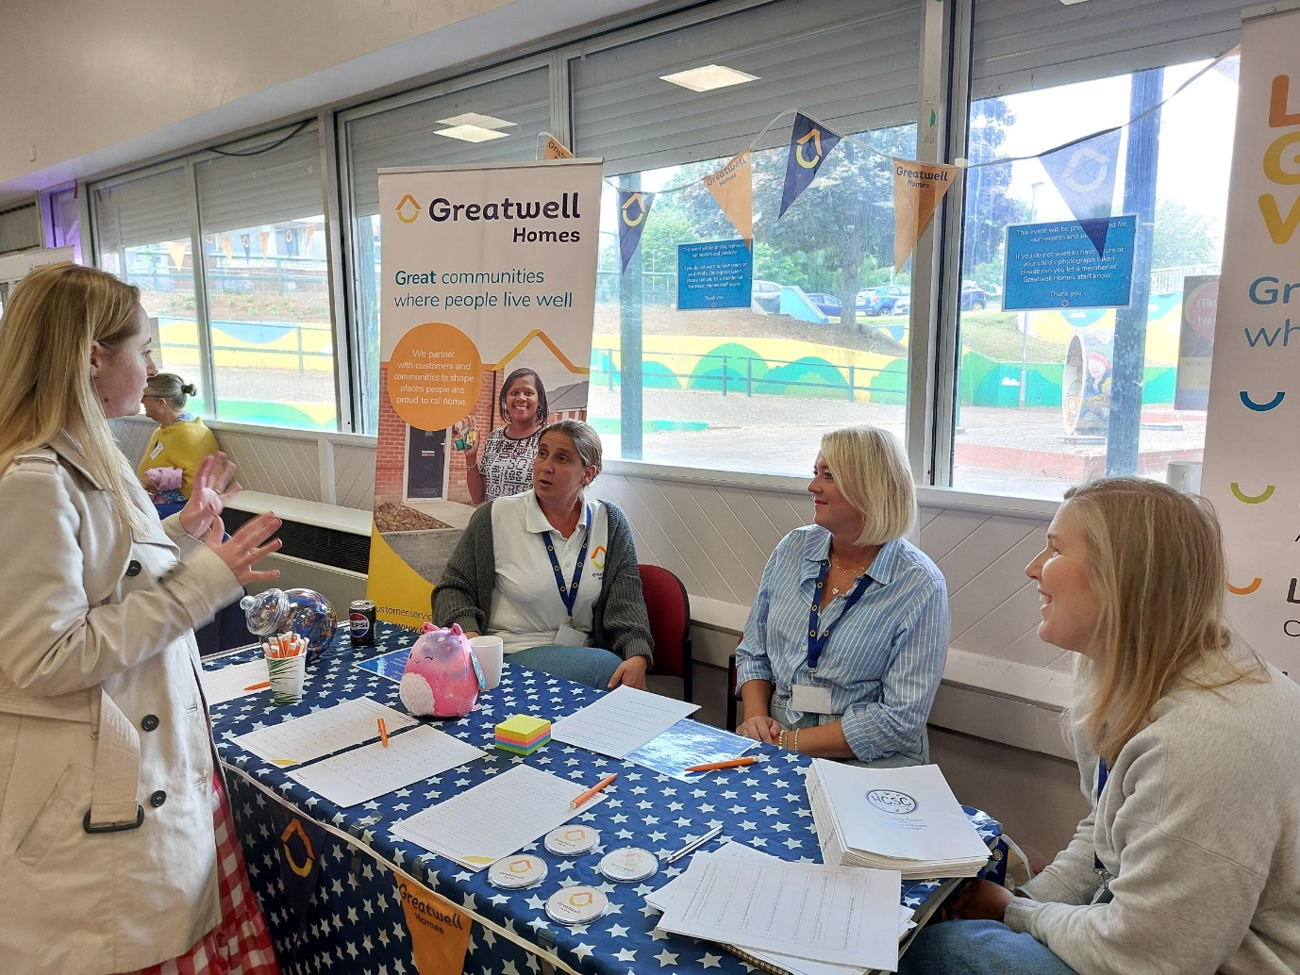

On Saturday 8th June, Hemmingwell held its annual Community Fun Day, which was enthusiastically supported by the Wellingborough community. This significant event helps solidify the unity of our communities, offering both young and old the opportunity to talk, play, and eat together.

Throughout the day, more than 100 people participated, bringing with them laughter, love, and plenty of food. A variety of stalls were available, ranging from face painting to a clothing swap shop hosted by the Wellingborough Eco Group, and a good old-fashioned jumble sale.

Greatwell Homes staff attended, including Lorraine Gibson, Community Involvement Officer and Housing Officer Sarah Marriot, who engaged attendees with games like "Guess the Number of Sweets in the Jar," and spent time with customers who simply wanted a chat. Also present were Katherine Goodwin, Housing & Income Manager, and Lizzie Brown, Community Involvement Manager. It was heartening to see such strong support from Greatwell Homes within our community.

We are always proud to support our community events, recognizing the immense value of community spirit and demonstrating that we are much more than just a landlord!

