Queensway Fun Day in June

I was thrilled to be part of the Queensway fun day on Saturday 15th June, where Together Greatwell had the opportunity to host a stall at St. Mark's Church. We were blessed with sunshine after many days of rain, and the community turned out in droves. Together Greatwell (Greatwell Homes’ customer equality, diversity and inclusion group) arrived early to set up, which gave us time to connect with other stallholders, some of which have been attending this annual community day for many years.
There was a wonderful variety of offerings from the stallholders, including raffle prizes, cake sales, and beautiful handmade crafts. As the morning progressed, the hall became increasingly busy, soon filling with parents, pushchairs, and savvy shoppers! The aroma of freshly baked bread and cakes filled the room, and the warm ambience of chatter was delightful. It was heartwarming to see so many people supporting the event and enjoying themselves.
Together Greatwell took the opportunity to showcase all the great work happening at Greatwell Homes, with many people discovering that we are more than just a landlord. We had questionnaires to ask customers about how they like to talk to us and what we can do to improve; and we spoke to our customers about their experiences.
As well this, we had some games and free give aways for the children, which is always nice. We were proud to recruit a couple of our Greatwell Homes customers to join the Together Greatwell panel, as they had never previously been involved.
The day was a success overall, allowing us to engage with many people, whether they were our customers or not. It was fantastic to represent Greatwell Homes and share the hard work that Together Greatwell is doing. Being visible in the community is so important, and the conversations we had with both young and old were invaluable. Great work, Together Greatwell!

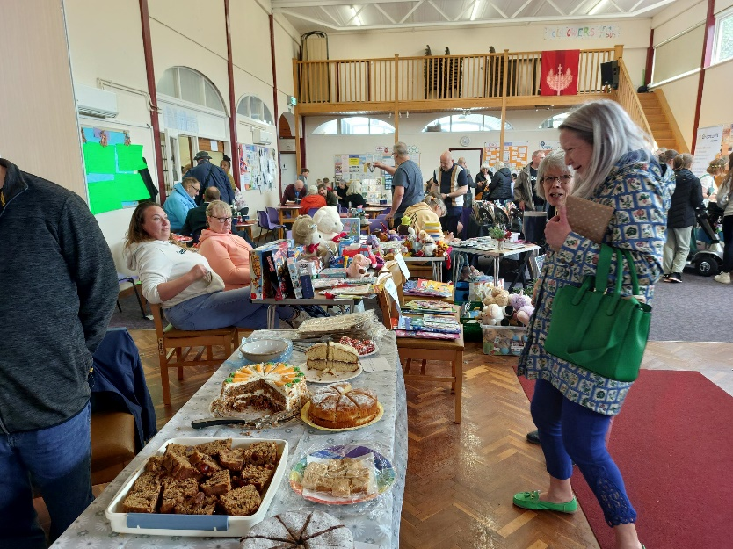
Stalls at St Marks Church fun-day.

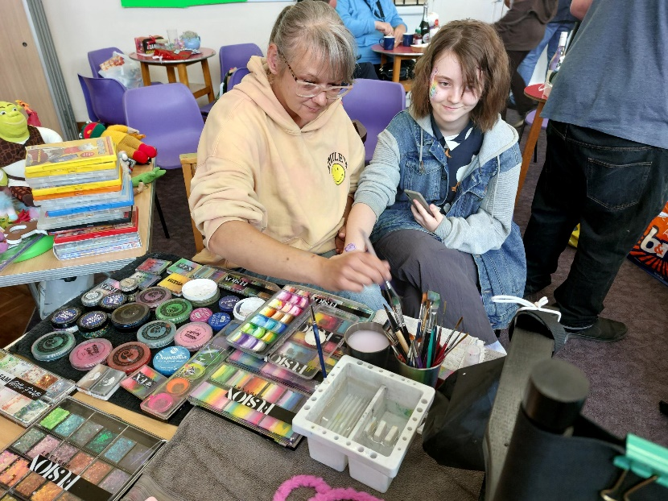
Face painting at the Queensway fun-day. Family fun.

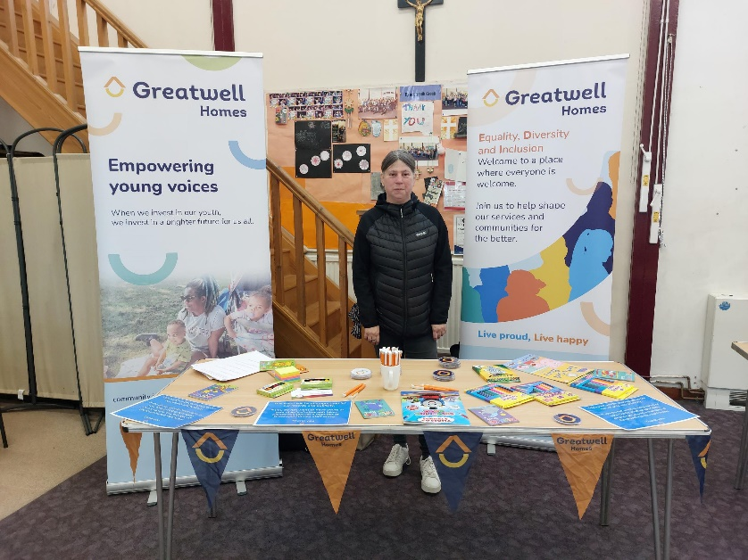
Together Greatwell’s stall at the Queensway fun-day.

