Celebrating the 75th anniversary of the ‘Windrush’.

**The day celebrates the contribution and achievements of the Windrush generation and their descendants.**

In June this year, the Community Involvement Team has been actively engaging with and supporting various community events. We are especially proud to have financially supported our Caribbean community in their significant 75th Windrush celebrations on Saturday 22nd June. The annual raising the flag ceremony is a notable event, attended by the Mayor, Councillors, Community Leaders, and, importantly, members of our local community. Our contribution from Greatwell Homes was even mentioned on BBC radio by the local organizers.

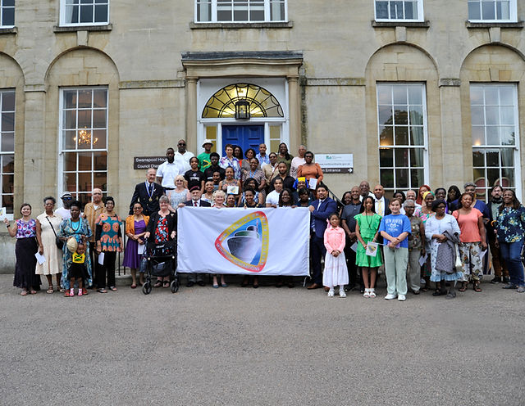The Community Involvement Team is committed to ensuring that we support community events and remain actively involved with our customer engagement.

Official photo from the Windrush event in Wellingborough

**A Little Piece of History:**

The term ‘Windrush’ derives from the name of the HMT Empire Windrush ship, which brought one of the first groups of Caribbean people to the UK in 1948. At the time, the Caribbean was part of the British Commonwealth, and those who arrived were automatically British subjects, free to permanently live and work in the UK. Despite facing challenges, they integrated and helped rebuild Britain.

Approximately one-third of the Empire Windrush’s passengers were RAF airmen returning from leave or veterans re-joining the Service. According to a passenger on the ship, the journey from Jamaica to the UK took about 22 days, which was considered a long journey at the time.

The Empire Windrush was built in Germany and launched in Hamburg on December 13, 1930. However, the ship was not originally called the Empire Windrush; it was initially named the MV Monte Rosa.

Following the Second World War, the British government needed help to rebuild Britain and invited its Commonwealth citizens from the Caribbean to assist in restoring the economy. Caribbean countries were also struggling economically, and job vacancies in the UK presented opportunities for many. A significant number of women who made the journey to Britain became nurses in the newly established NHS and/or worked in public transport. The Windrush generation made substantial contributions to the NHS, both as healthcare professionals and patients, with many already possessing medical training and qualifications, helping to fill critical gaps in our healthcare system.

Tickets for the ‘Windrush’ at the time were priced at 10 shillings, which is the equivalent of £1,000 to £1,200 in today’s money, according to UK Retail Price Index (RPI).

The Windrush community has made significant contributions to Britain’s economy at all levels throughout the country and we wanted to be part of the celebrations.

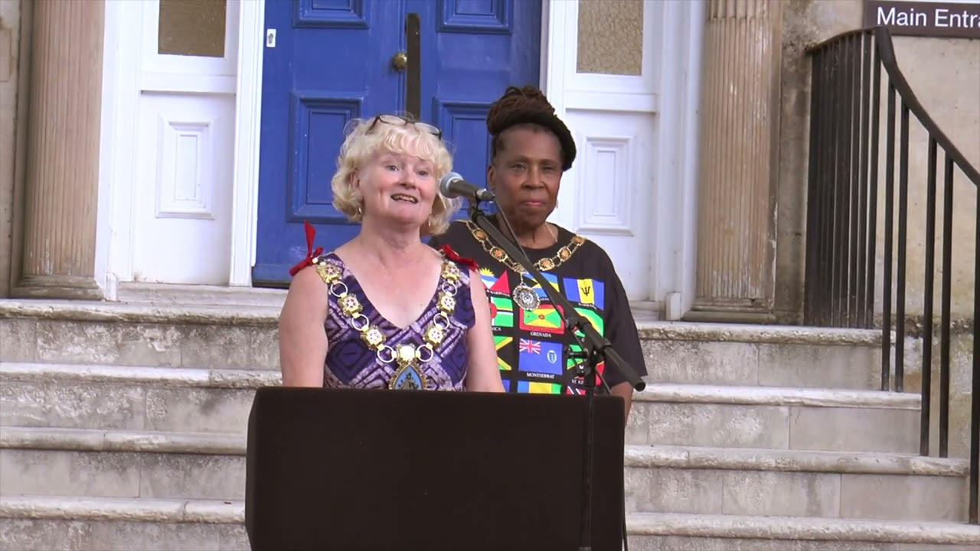

Councillor Sylvia Erskine (behind) Mayor of Wellingborough Councillor Valarie Anslow (front)